**Agenda: Introduction to Cloud Computing**

* What is Cloud Computing.
* Cloud Characteristics.
* Cloud Computing Service Models.
* Deployment Models in Cloud Computing.
* Advantages and Disadvantages of Cloud Computing.
* Cloud Computing Job Roles.
* Cloud Computing Platforms and Certifications.

**What is Cloud Computing?**

* **Cloud** is just a metaphor for the internet, when we say cloud, we are just referring to internet.
* In the simplest terms, **cloud computing** means storing and accessing data and programs over the Internet instead of our local computer's hard drive.

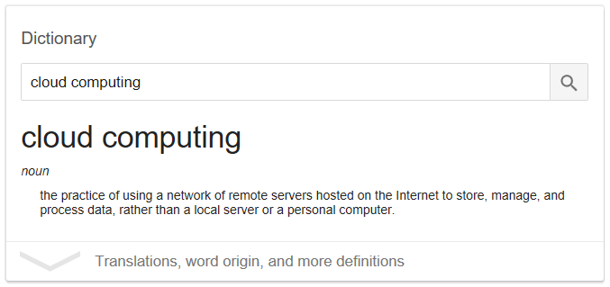

* The phrase **cloud computing** means "**a type of** **Internet-based computing**" where different services — such as servers, storage and applications — are delivered to an organization's computers and devices through the **Internet**.
* Cloud Computing refer to a variety of **services** available over the Internet that deliver computing functionality on the **service provider's infrastructure**. One has to just **rent** it to use the same.
* The computing services offered tend to vary by cloud provider. However, typically they include:
* **Compute power** - such as Windows and Linux virtual machines
* **Storage** - such as object storage
* **Applications** - such as NoSQL or SQL database applications
* **Networking** - such as setting up virtual networks for your virtual machines
* **Analytics** - such as visualizing telemetry, and performance data
* A cloud computing service consists of highly **optimized data centers** (third party data centers from the end user point of view), that provide various hardware, software and information resources (when needed).
* Cloud platform **hide the complexity** and details of the underlying infrastructure from users and applications by providing very simple graphical interface or API (Applications Programming Interface).
* The Cloud platform provides **on demand services** that are **always on, anywhere, anytime and anyplace**.

**Why are businesses moving to cloud?**

In traditional hosting, a software company has to deal with licensing costs, protection of data, frequent upgrades to latest technologies, maintenance and up gradation of hardware and most important finding the right skillsets at the right time.

**Cloud Characteristics**

**Characteristics** of Cloud computing that distinguish it from **traditional hosting**.

* **Remotely hosted**: Services or data are hosted on remote infrastructure.
* **Ubiquitous**: Services or data are available from anywhere through internet.
* **Resiliency**: Cloud providers generally mirrors solutions to multiple data centers to minimize downtime in the event of a disaster.
* **On-demand self-service**: A consumer can himself provision computing capabilities, such as server time and network storage, as needed automatically without requiring human interaction with each service’s provider. It is sold on demand mostly by the minutes or hours. (Pay as you go model)
* **Rapid elasticity** – A user can utilize as much or little of the cloud service as required. For example resources (ex: webservers) on the cloud can be scaled to meet high traffic in peak times or scaled down in times of less traffic.
* **Broad network access**. Capabilities are available over the network and accessed through standard mechanisms that promote use by heterogeneous thin or thick client platforms (e.g., mobile phones, laptops, and PDAs).
* **Fully managed by the provider / It's current** - The user is abstracted from the details of how the service is managed in the cloud. For example the user need not worry about aspects such as hardware used, software updates and patches, plug-ins, web security. There is optimum utilization of resources and as well as sharing of resources. Everything is taken care of by the provider.

**Cloud Computing Service Models**

**Cloud Computing = Software as a Service (SaaS)  
 + Platform as a Service (PaaS)  
 + Infrastructure as a Service (IaaS)  
1) IaaS** (Infrastructure as a Service):

* 1. Delivers computer infrastructure, typically a platform virtualization environment as a service.
  2. Cloud providers build datacenters, managing power, scale, hardware, networking, storage, distributed systems, etc…
  3. Rather than purchasing servers, software, data center space or network equipment, clients instead buy those resources as a fully outsourced service.
  4. Eg: Amazon Web Services(AWS), Rackspace Hosting, VMWare, Citrix, Azure, Google Cloud

1. **PaaS** (Platform as a Service):
   1. Provides **developer's** necessary tools to create, test, host and maintain created applications.
   2. Cloud providers offer an Internet-based platform to developers who create services but don't want to build their own cloud.
   3. Ex: Microsoft Azure, Google Cloud, AWS
2. **SaaS** (Software as a Service):
   1. SaaS is a software delivery methodology that provides licensed multi-tenant access to software and its functions remotely as a Web-based service.
   2. From **end user’s** point of view apps are located in the cloud and it is almost always accessible through a web browser.
   3. Any application hosted on a remote server that can be accessed over the Internet is considered as SaaS.
   4. Usually billed based on usage and a multi-tenant environment.
   5. Ex: Microsoft Azure, Gmail, Google Apps (Office like features), Sales Force CRM

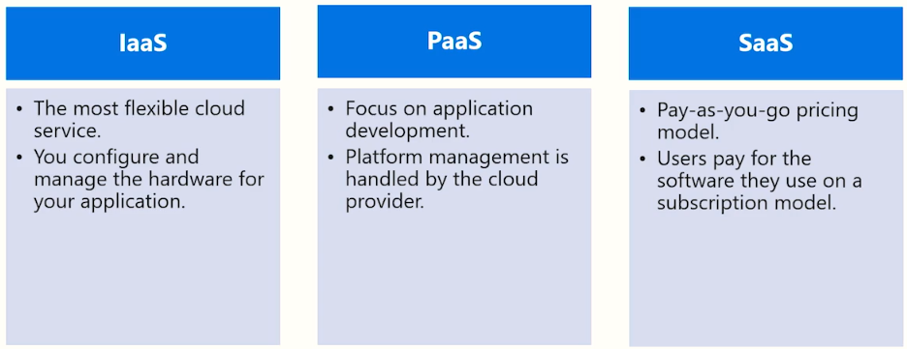

AdvantagesAdvantages
• Lower computer costs
• Improved performance:
• Reduced software costs
• Instant software updates
• ...

The following picture neatly summarizes the functionality of the three service models of the cloud.

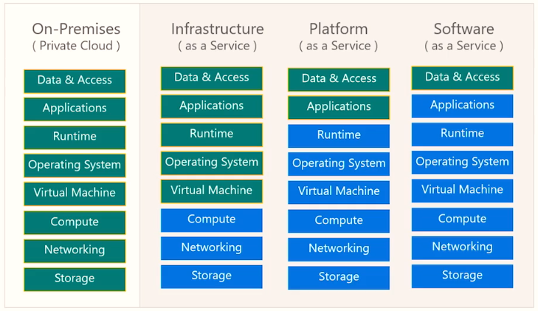

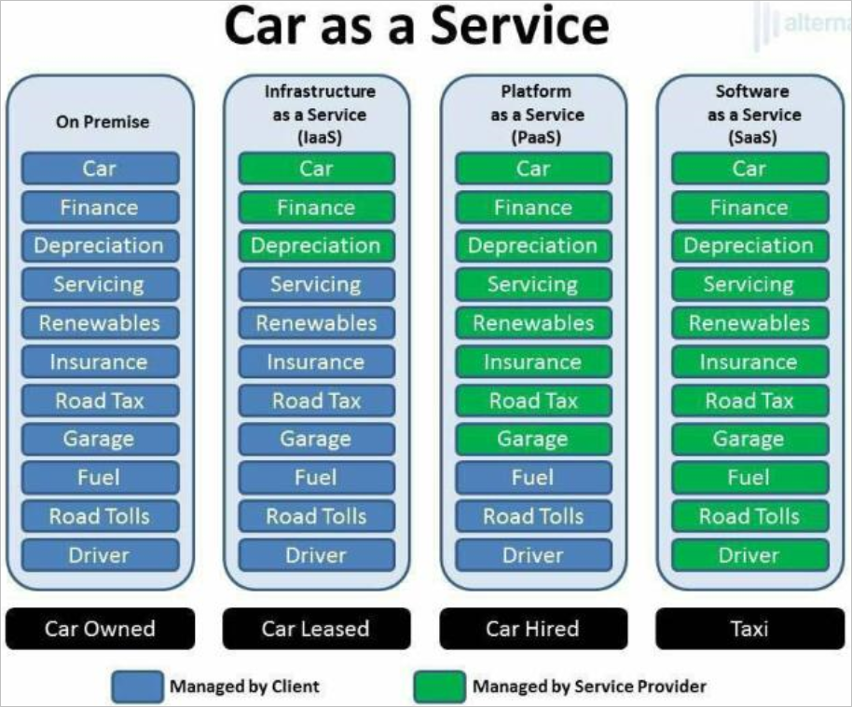

**Deployment Models in Cloud Computing**

There are three main deployment models in Cloud Computing.

1. **Public Cloud**:
   * These are the clouds which are open for **use by general public** and they exist beyond the firewall of an organization, fully hosted and managed by vendors.
   * Your data is stored in the provider’s data center and the provider is responsible for the management and maintenance of the data center.
   * Because you are sharing computing resources among a network of users, the public cloud offers greater flexibility and cost savings.
   * This is good option if your demand for computing resources fluctuates. You have to purchase the capacity on the basis of usage and can scale up or scale down server capabilities based on traffic and other dynamic requirements.
   * This type of cloud environment is appealing to many companies because it reduces lead times in testing and deploying new products.
   * Cons: They are more vulnerable than private clouds and there is no control of resources used or who shares them.

Note: Even though you don’t control the security of a public cloud, all of your data remains separate from others and security breaches of public clouds are extremely rare.

1. **Private Cloud**:
   * A private cloud hosting solution, also known as an **internal** or **enterprise** cloud, resides on company’s intranet or hosted data center where all of your data is protected behind a firewall.
   * This can be a great option for companies who already have expensive data centers because they can use their current infrastructure.
   * You go for a private cloud when you have strict **security and data privacy** issues.
   * Cons: The main drawback people see with a private cloud is that all management, maintenance and updating of data centers is the responsibility of the company.
2. **Hybrid Clouds**:
   * They consist of external and internal providers, namely a mix of public and private clouds.
   * Secure & critical apps are managed by an organization and the not-so-critical & secure apps by the third party vendor. For example, you can use a public cloud to interact with the clients but keep their data secured within a private cloud. Most companies are now switching to Hybrid clouds.
   * Ideal in situations where you have plans are to migrate to a complete cloud solution as existing hardware expires or you have some applications or hardware that are not ready for the cloud.

